TASK ON S3
Create an S3 bucket and upload some objects to S3.
To create Bucket we need Go To S3 service click create bucket Use a unique name and create bucket and upload the file
Created the bucket and updated the object
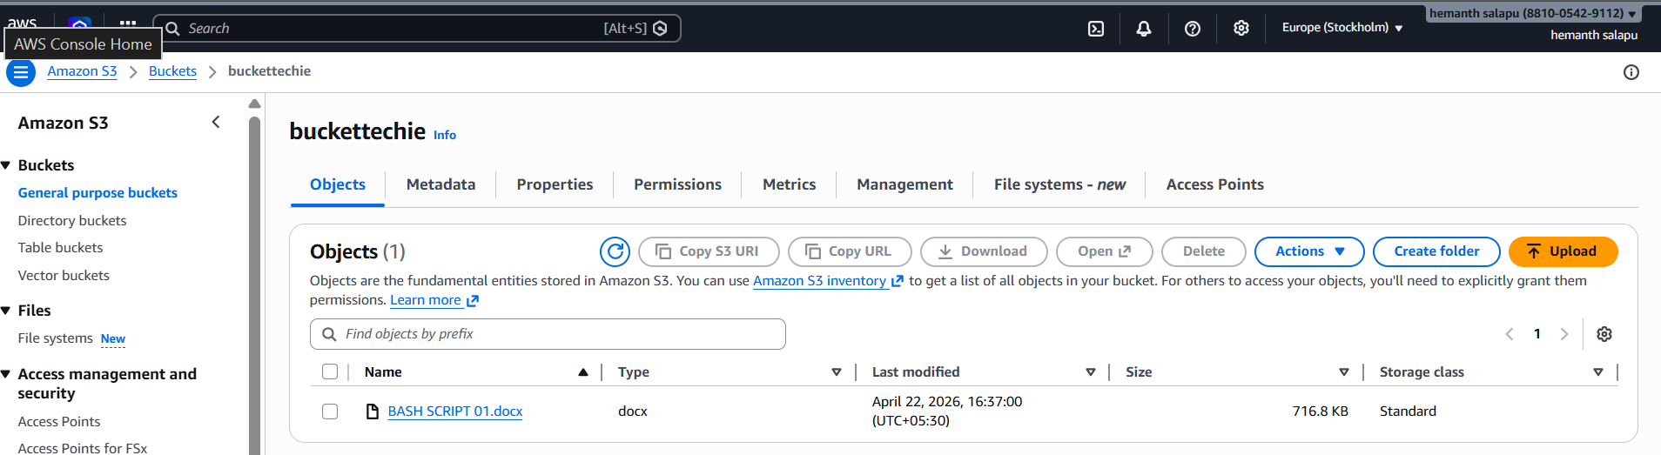
Deploy a static website in the S3 bucket.
Enable static website hosting in bucket properties.
Upload HTML files and allow public read access to access via URL.

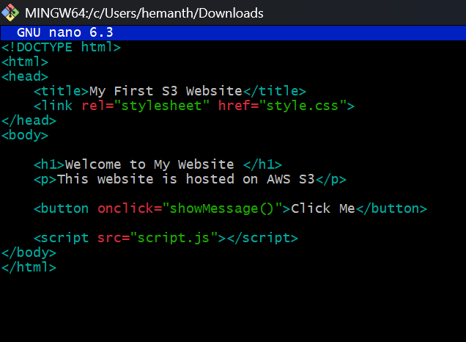
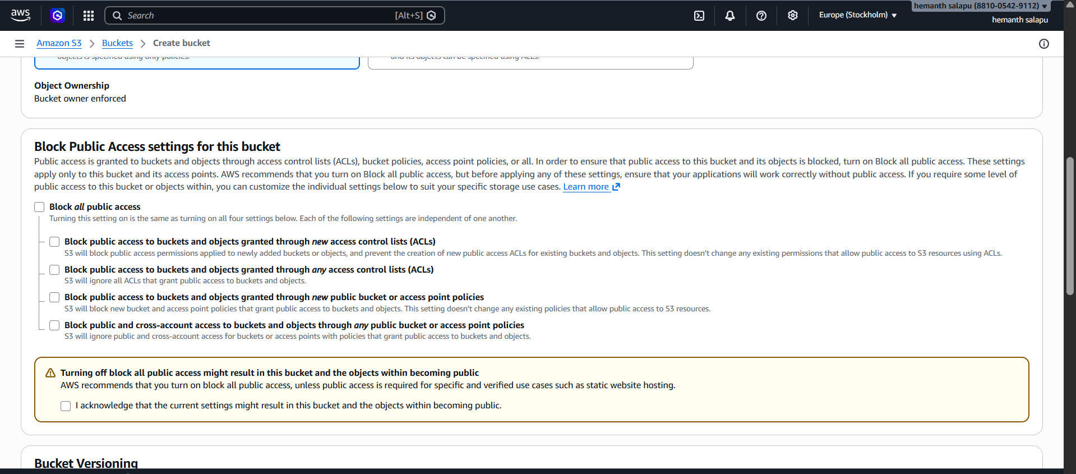
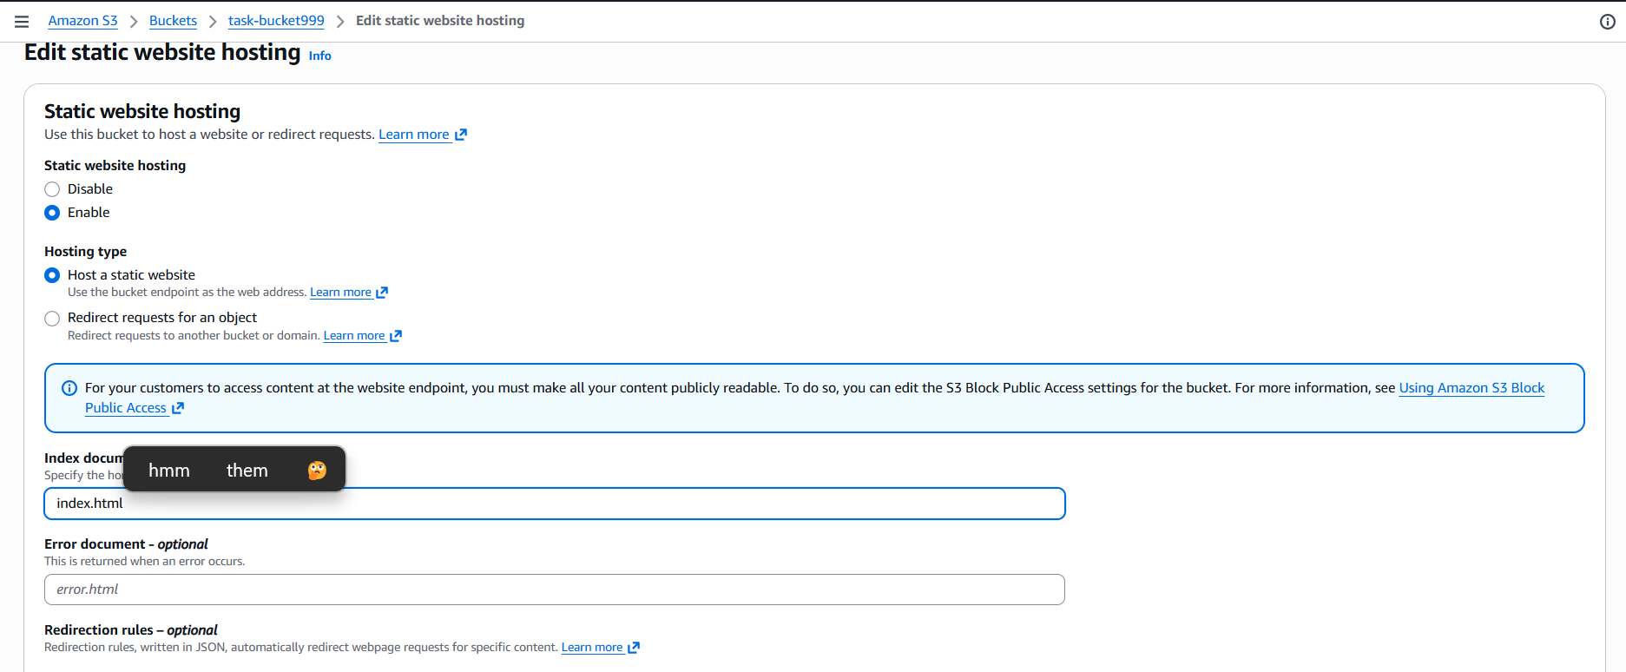
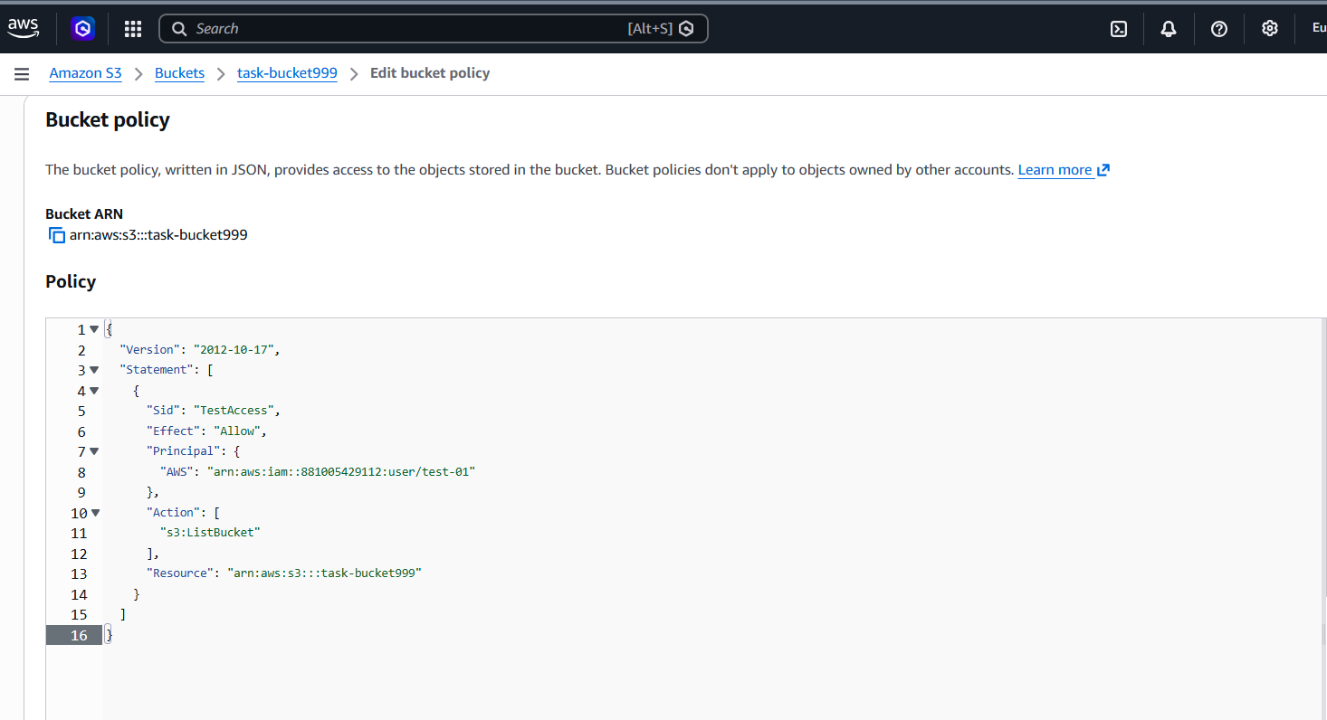
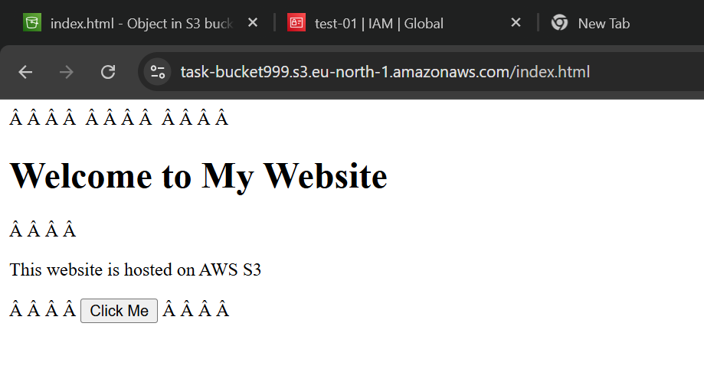

Enable cross-region replication on S3 buckets.
Create two buckets in different regions and enable versioning.
Configure replication rule with an IAM role.

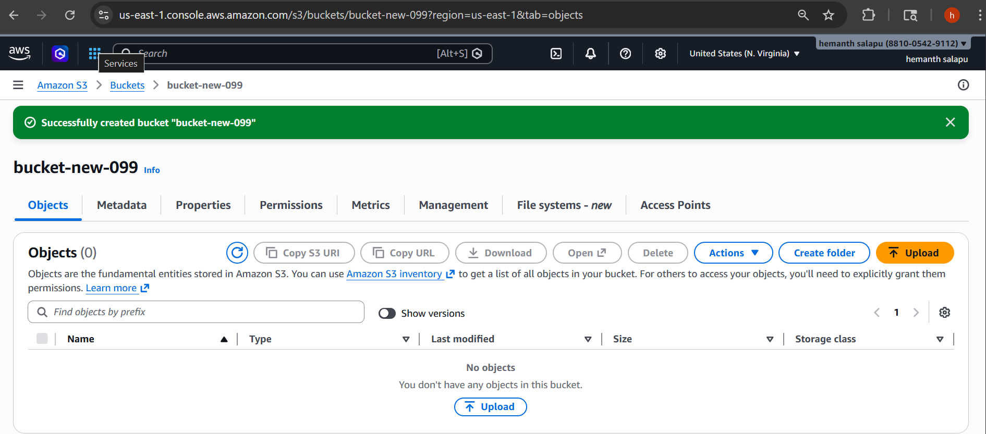
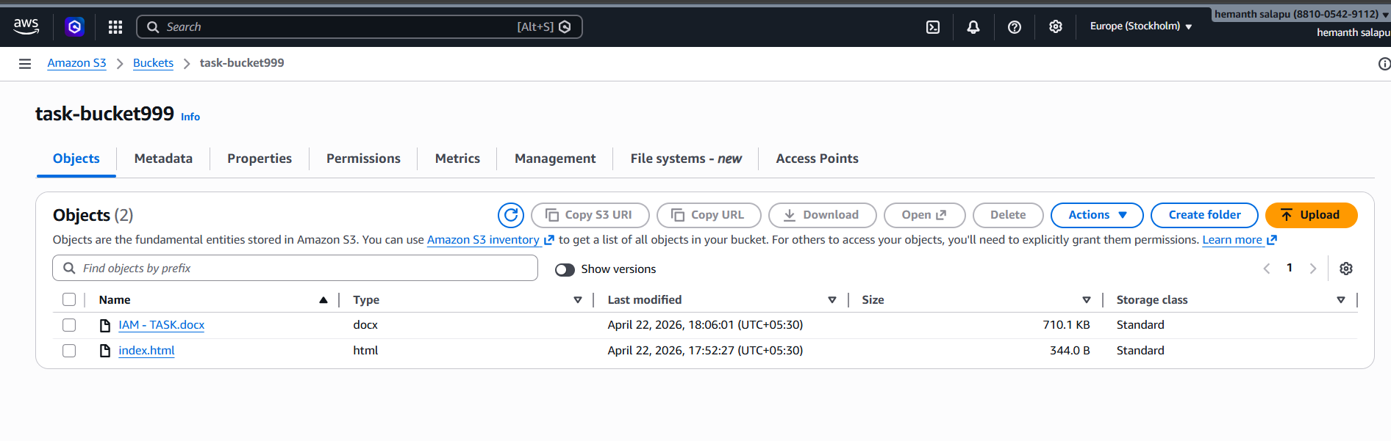
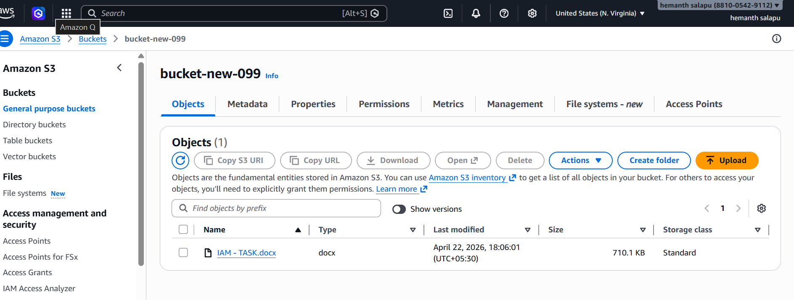

Configure a bucket policy so only the Admin user can see the objects of the S3 bucket.
Add a bucket policy allowing only the Admin IAM user.
Grant permission to view/download objects
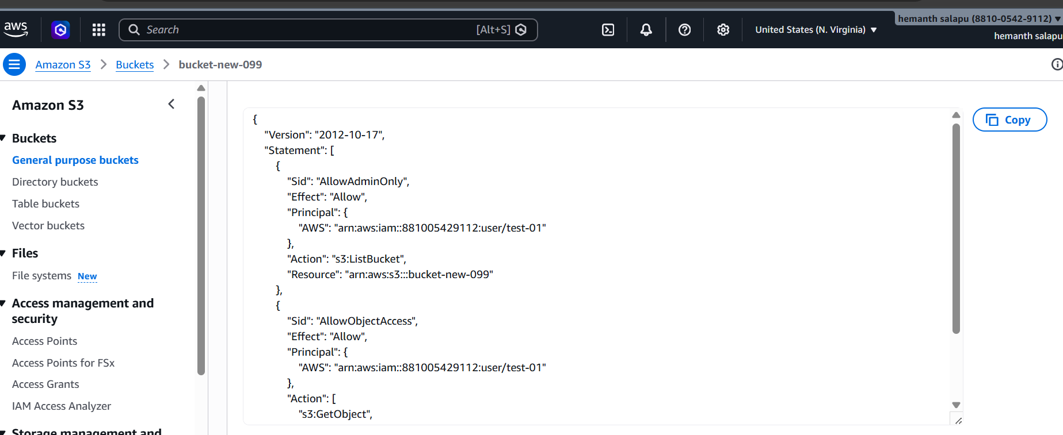
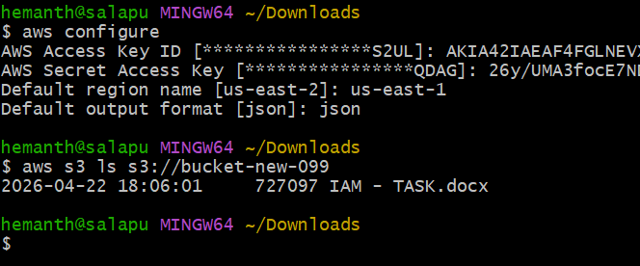

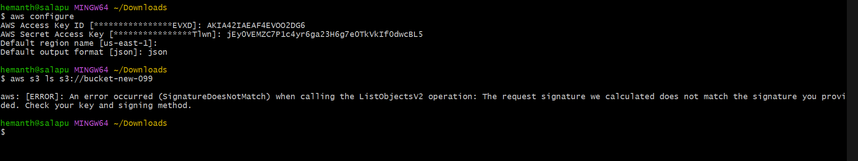

Set up lifecycle policies to automatically transition or delete objects based on specific criteria.
Create lifecycle rule in Management tab.
Set transition (e.g., Glacier) and expiration (delete after days).
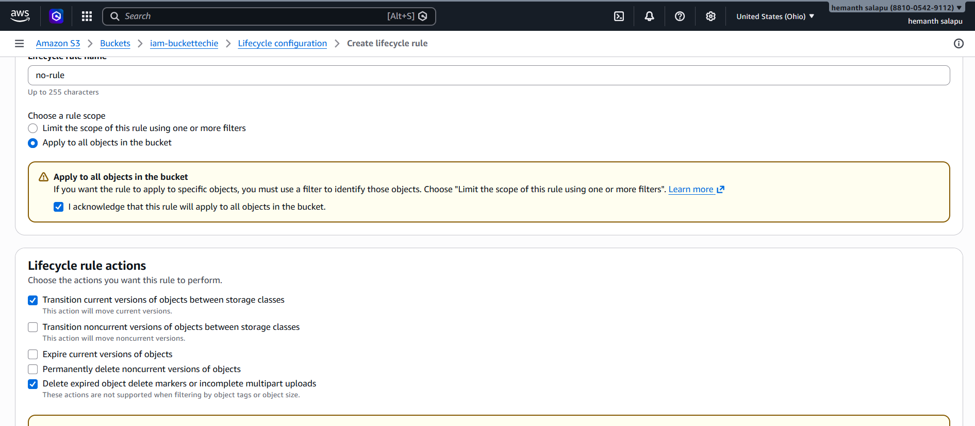
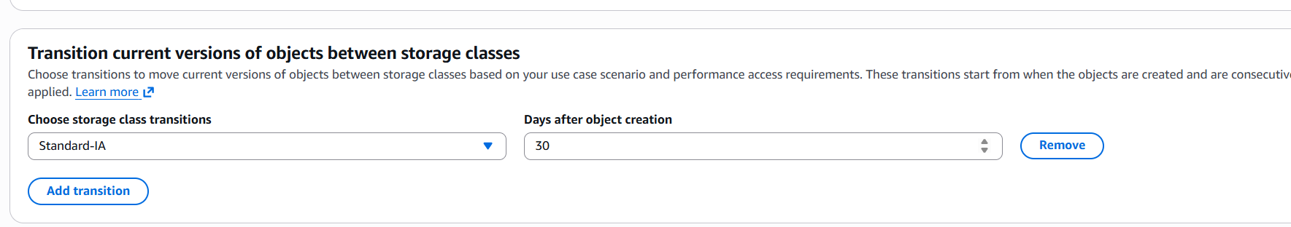
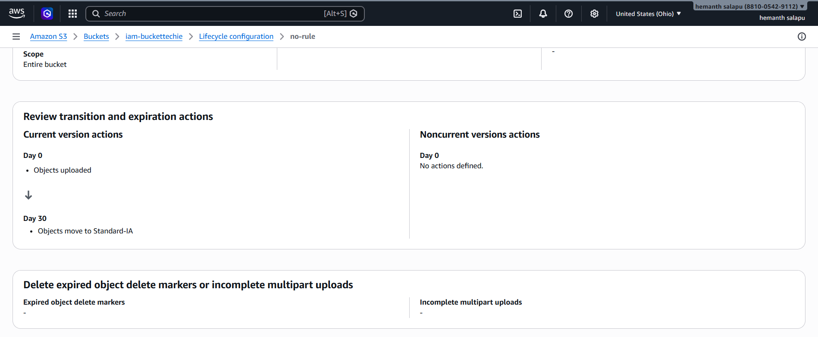

Push some objects to S3 using the AWS CLI.
Configure AWS CLI with credentials.
Upload files using S3 CLI command and verify in bucket.
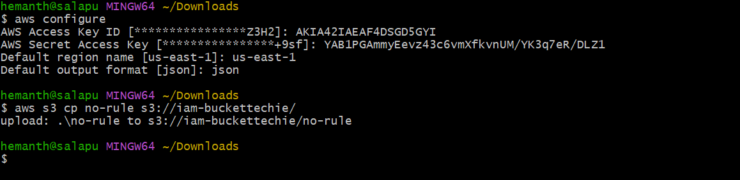
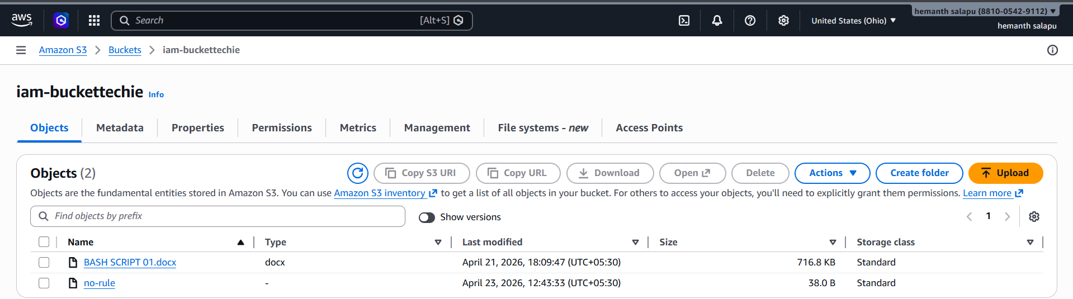

Write a Bash script to create an S3 bucket.
Write a script with AWS CLI command to create bucket.
Run the script after making it executable.
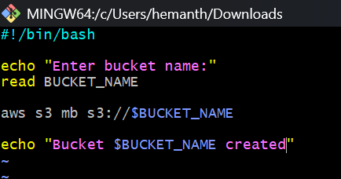
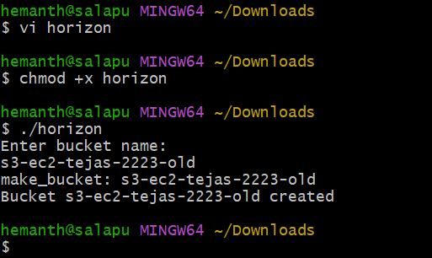
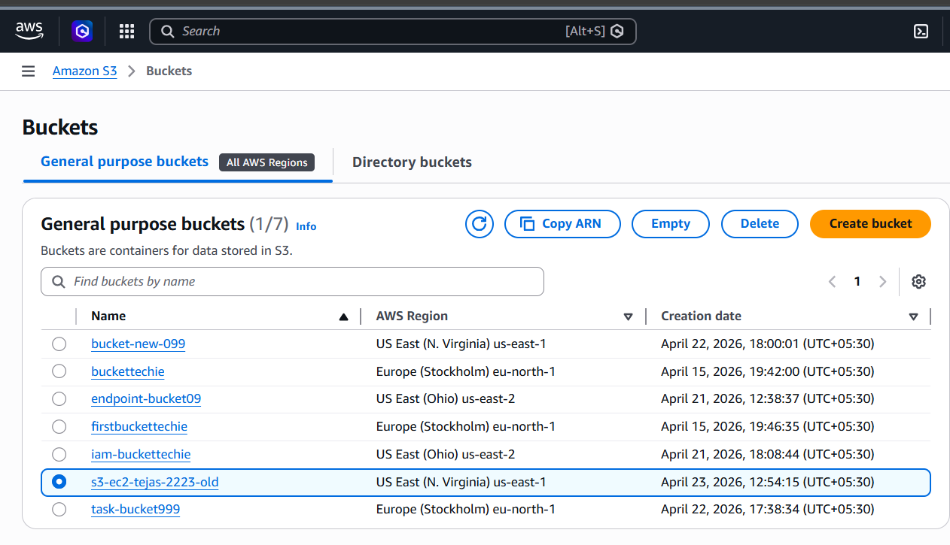
Upload a 1 GB file to S3 using the CLI.
Create a 1GB file locally.
Upload using CLI; multipart upload happens automatically.
